**Project Design Phase-II**

**Data Flow Diagram & User Stories**

**Data Flow Diagram:**

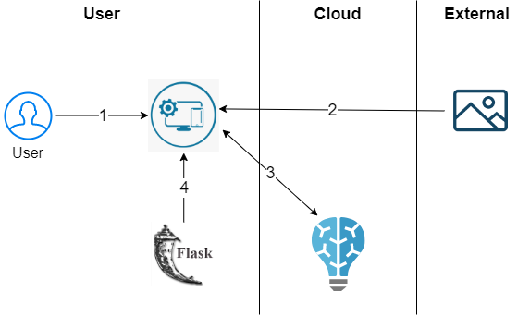.

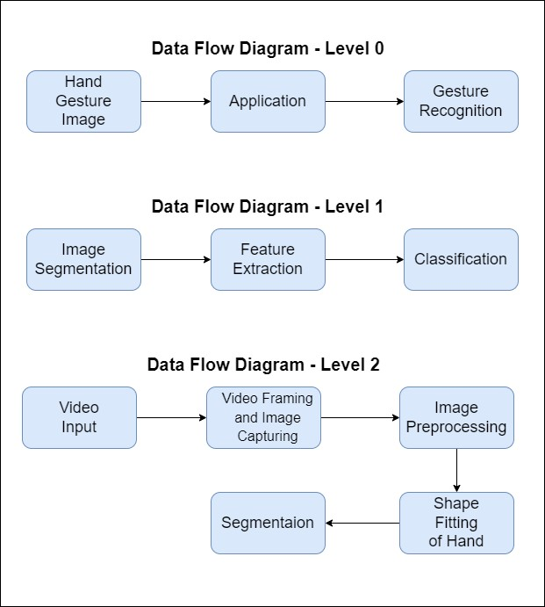

**User Stories**

Use the below template to list all the user stories for the product.

|  |  |  |  |  |  |  |
| --- | --- | --- | --- | --- | --- | --- |
| **User Type** | **Functional**  **Requirement**  **(Epic)** | **User Story Number** | **User Story / Task** | **Acceptance criteria** | **Priority** | **Release** |
| Customer (Web user) | Launch Web App deployed in cloud | USN-1 | As a user, I can launch the webapp where I can upload the images for recognition | I can upload the images for classification | High | Sprint-4 |
|  | Prediction | USN-2 | As a user, I can get the predicted results from the model deployed in the cloud | I can resize the radiology image, blur the image, flip based on the hand gesture | High | Sprint-4 |
|  | Deployment of webapp in the cloud | USN-3 | As a user, I need the webapp to be accessible all over the world | I can access the webapp deployed in the IBM cloud | Medium | Sprint-3 |
|  | Deployment of AI model in the cloud | USN-4 | As a user, I need the AI model to be accessible all over the world | I can access the model deployed in the IBM cloud | Medium | Sprint-3 |
|  | Model Building | USN-5 | As a user, I need an AI model which could classify or recognize the hand gestures | I can get the prediction from the AI model | Medium | Sprint-1 |
|  | User Interface  Building | USN-6 | As a user, I need a web app for human computer interaction | I get User Interface for interaction with the model | Medium | Sprint-2 |